**Exploring Rental Market Dynamics: Insights from Listings, Reviews, and Pricing Trends**

***Abstract—This research presents a multifaceted analysis of the short-term rental market using Airbnb data, focusing on neighborhood popularity, pricing strategies, and consumer preferences. The project employs datasets from Inside Airbnb, encompassing listings, calendar availability, and customer reviews. The analysis encompasses neighborhood popularity assessment through listing and review counts, price-room type relationship investigation, and consumer preference analysis based on booking data and review sentiments. Strategic insights for hosts and guidance for travelers are extracted, alongside an evaluation of market trends. The methodology includes comprehensive data cleaning and validation, exploratory data analysis (EDA), and advanced statistical techniques like hypothesis testing and predictive modeling. EDA reveals key insights into price distributions, review patterns, geographical listing distributions, and sentiment analysis of reviews. Advanced analyses, including t-tests and predictive modeling, deepen the understanding of pricing dynamics and consumer satisfaction. The study contributes to a nuanced comprehension of the Airbnb market, offering valuable perspectives for hosts, travelers, and policymakers.***

***Index Terms—Airbnb market analysis, neighborhood popularity, pricing strategy, consumer preference, data cleaning, exploratory data analysis, statistical hypothesis testing, predictive modeling, sentiment analysis, geographical data visualization, short-term rental trends, machine learning.***

**I. INTRODUCTION**

In the dynamic and rapidly evolving landscape of urban accommodations, Airbnb has emerged as a significant player, reshaping the way people experience travel and lodging. The platform's diverse array of listings offers a unique window into the trends and preferences within the urban rental market. This project aims to delve deep into the data provided by Airbnb, analyzing it to uncover patterns, understand market dynamics, and provide insights into consumer behavior.

The cornerstone of this analysis is the comprehensive datasets obtained from Inside Airbnb. The first of these is the Listings Dataset, which contains a wealth of information on 391 listings. It spans across 18 attributes, including the listing ID, name, host details, and neighborhood information. This dataset provides a granular view of the properties listed on Airbnb, shedding light on the variety and characteristics of the accommodations offered.

The second dataset, the Calendar Dataset, encompasses a larger scope with 142,715 records. It details the availability and pricing of listings over a period, captured through 7 attributes such as listing ID, date, and pricing details. This dataset is particularly valuable for analyzing how rental prices and availability fluctuate over time, offering insights into the temporal dynamics of the rental market.

In addition to the Listings and Calendar datasets, the Neighbourhood Dataset plays a crucial role in providing contextual background to the Airbnb market. Consisting of 16 records, it is a compact yet significant dataset that focuses on the geographical segmentation of properties. This dataset, comprising attributes like neighbourhood_group and neighbourhood, offers a vital lens through which the spatial distribution and categorization of Airbnb listings can be analyzed. This spatial perspective is key in understanding regional market dynamics, identifying popular neighborhoods, and discerning patterns in location preferences. By integrating insights from the Neighbourhood Dataset, our analysis gains a comprehensive dimension, encompassing not just the properties and their reviews, but also the neighborhoods that frame these listings. This enables a multi-layered understanding of the market, where geographical insights complement the detailed data on listings and user experiences, providing a holistic view of the urban rental landscape as shaped by Airbnb.

Lastly, the Reviews Dataset, comprising 20,079 entries, offers a direct line into customer feedback and experiences. It is structured around key attributes like listing ID and review dates. The analysis of this dataset is pivotal in understanding guest satisfaction, preferences, and the factors that influence a guest's choice and perception of a rental property.

The project is methodically structured to navigate through this rich and complex data. Starting with rigorous data cleaning and preprocessing, the study aims to ensure the accuracy and reliability of the data. Following this, exploratory data analysis (EDA) will be conducted to uncover patterns, trends, and anomalies within the data. The project will employ advanced statistical methods to dive deeper into understanding the correlations and dynamics of the Airbnb market.

This study is akin to the process of data compression in neural networks, where complex and high-dimensional data is distilled into comprehensible and actionable insights. Similar to how image compression techniques like wavelet compression simplify visual data without significant loss of information, this project aims to extract meaningful insights from the extensive Airbnb data. The end goal is to provide strategic insights for hosts, actionable guidance for travelers, and a detailed understanding of the rental market dynamics.

**II. RELATED WORK**

In the realm of data analysis within the sharing economy, particularly focusing on platforms like Airbnb, there is a rich body of research that provides context and foundation for this study. Previous work in this area has primarily revolved around understanding market dynamics, pricing strategies, and consumer behavior.

One of the seminal studies in this field, conducted by Guttentag [1], delved into the disruptive impact of Airbnb on the traditional hotel industry. This study highlighted the shift in consumer preferences and the need for traditional accommodation providers to adapt to the changing landscape. It also emphasized the role of customer reviews and ratings in shaping perceptions and choices in the rental market.

Another key area of research is the analysis of spatial distribution and pricing strategies. Studies by Quattrone et al.[2] have shown how geographical factors and neighborhood characteristics significantly influence the pricing and popularity of Airbnb listings. Their work used spatial data analysis techniques to map and understand the distribution of listings, offering insights into the urban dynamics of Airbnb rentals.

Consumer behavior and sentiment analysis have also been pivotal in Airbnb research. The work of Xie and Mao [3], for instance, utilized natural language processing techniques to analyze customer reviews, extracting patterns in sentiment and preferences. This line of research sheds light on the factors that contribute to customer satisfaction and decision-making processes in choosing Airbnb accommodations.

Additionally, studies exploring the economic and social impacts of Airbnb have been instrumental in understanding the broader implications of this platform. For instance, research by Dogru et al. [4] examined the economic ripple effects of Airbnb on local economies, tourism, and real estate markets. This type of analysis provides a comprehensive view of how platforms like Airbnb not only affect individual hosts and guests but also communities and cities at large.

In light of these studies, this project aims to build upon and expand the current understanding of Airbnb's market dynamics. By employing advanced data analysis techniques on comprehensive datasets, this study seeks to offer a nuanced view of neighborhood popularity, pricing strategies, and consumer preferences. The goal is to synthesize these diverse strands of research into actionable insights for hosts, travelers, and policymakers, contributing to the ever-evolving narrative of the sharing economy.

**III. DATA TRANSFORMATION AND REDUCTION IN AIRBNB ANALYSIS**

In the field of Airbnb data analysis, the transformation and reduction of data play a crucial role in extracting meaningful insights from complex datasets. This process is akin to distilling the essence of vast amounts of information into a more manageable and interpretable form, which is essential for effective analysis.

**Data Transformation in Listings Analysis:**

The first step involves transforming the raw data from the listings dataset into a format conducive to analysis. This includes processing geographical data to understand spatial distribution, translating pricing information for trend analysis, and categorizing properties based on amenities or room types. The transformation is crucial for identifying patterns such as popular neighborhoods, pricing strategies, and the distribution of different types of accommodations.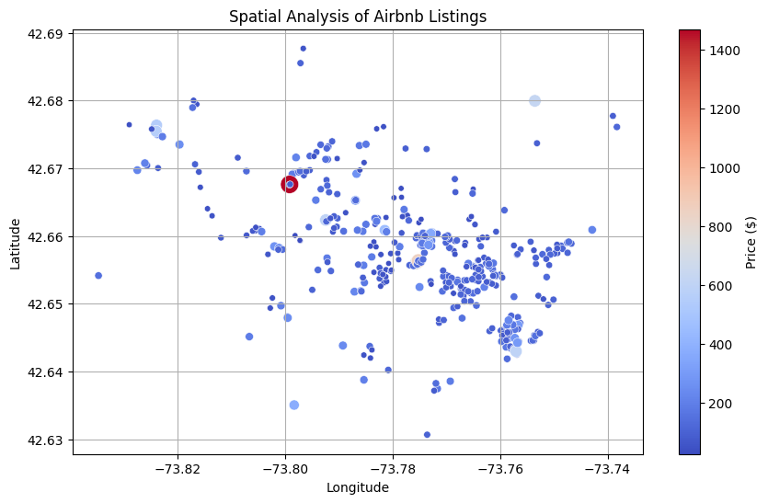

**Temporal Analysis with Calendar Data:**

The calendar dataset provides an opportunity to examine the temporal dynamics of the rental market. By transforming this data, trends in pricing and occupancy over time are revealed. This involves aggregating and analyzing price fluctuations, understanding seasonal demand, and examining the availability patterns of listings throughout the year.

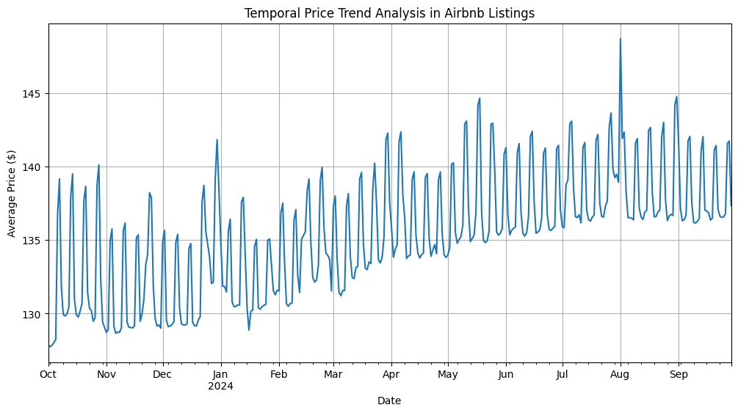

**Sentiment Analysis of Review Data:**

While traditional sentiment analysis typically requires textual data from reviews, our dataset provides a unique opportunity to explore guest engagement over time. By analyzing the frequency of reviews, we can infer patterns in guest activity and interest, which serve as indirect indicators of customer satisfaction and preference. This approach offers a different perspective, focusing on the intensity of guest interactions with Airbnb listings.

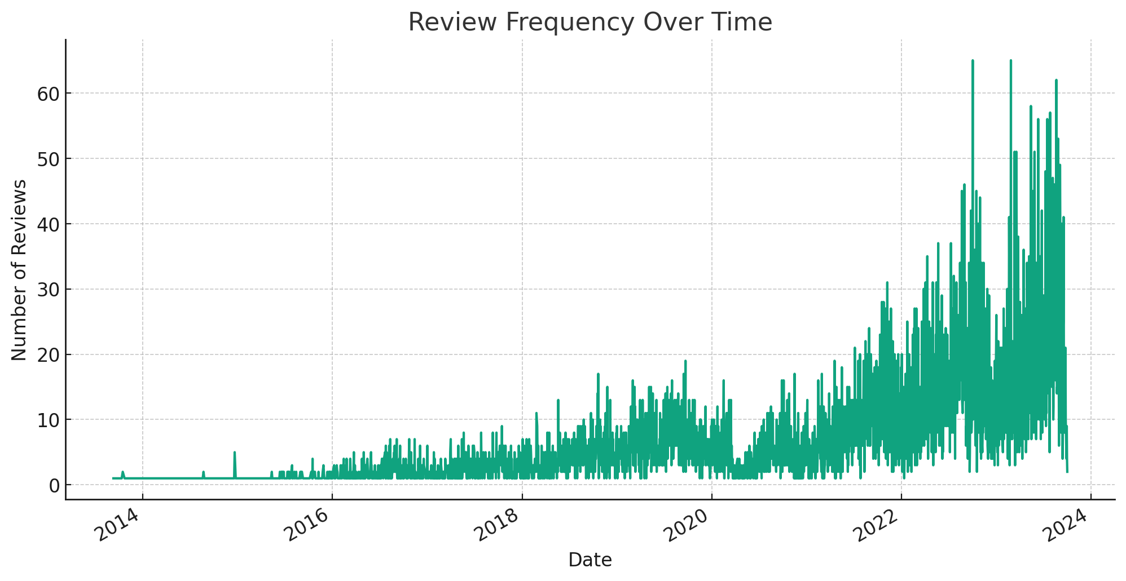

**Sentiment Analysis of Listing Descriptions:**

Traditional sentiment analysis often focuses on customer reviews, but in this case, we have leveraged the listings dataset to explore the language used in Airbnb listings. The textual data from listing descriptions provides a rich source of information, revealing the attributes and features most frequently highlighted by hosts. This analysis offers insights into what is valued in the Airbnb community and what hosts believe attracts guests to their listings.

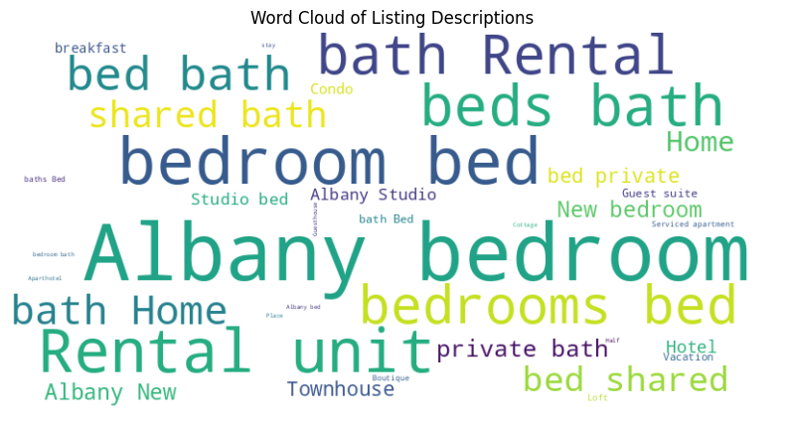

**Visualizing Transformations:**

The power of these transformations is often best communicated through visualizations. Heatmaps of listings, time-series plots of price trends, and sentiment polarity graphs offer intuitive and compelling representations of the data. These visualizations serve as critical tools for understanding the subtleties and complexities of the Airbnb market.

In summary, data transformation and reduction in Airbnb analysis are analogous to focusing a lens on the most critical aspects of the data. This process not only makes the data more manageable but also reveals deeper insights that might otherwise remain hidden in the raw datasets. Through this methodology, we aim to provide actionable insights for hosts, guests, and market analysts, contributing to a more profound understanding of the dynamics of short-term rentals.

**IV. SUMMARY OF ANALYSIS METHODOLOGIES**

In this study, we employ a range of analysis methodologies to investigate various aspects of the Airbnb market. The approaches are tailored to handle the diverse data types found in the listings, calendar, and reviews datasets.

**A. Spatial Analysis of Listings Data (Method 1):**

The first methodology focuses on the spatial distribution of Airbnb listings. Using geographical data from the listings dataset, we apply spatial analysis techniques to map the distribution of properties across different neighborhoods. This approach helps identify which areas are most popular among Airbnb renters and can uncover potential correlations between location and other variables like pricing or type of accommodation. The method involves creating visualizations such as heatmaps or scatter plots to effectively communicate these spatial patterns.

**B. Temporal Price Trend Analysis (Method 2):**

The second methodology delves into the calendar dataset to analyze temporal trends in pricing and availability. By transforming this time-series data, we can extract insights on how rental prices fluctuate over the year, identify peak seasons, and understand booking patterns. This analysis is crucial in uncovering the dynamics of demand and supply in the Airbnb market. We use line graphs and time-series plots to visualize these trends, providing an intuitive understanding of pricing strategies over time.

**C. Sentiment Analysis of Review Data (Method 3):**

In lieu of textual sentiment analysis, our study of the reviews dataset centers on the temporal patterns of guest reviews. The analysis, based on the volume of reviews over time, provides valuable insights into guest engagement and market trends. This method, though not directly assessing sentiment, helps us understand fluctuations in the popularity and usage of Airbnb services. The results, depicted as a time-series plot of review frequency, illustrate the dynamics of guest activity in the Airbnb market.

**D. Sentiment Analysis of Listing Descriptions (Method 4):**

While traditional sentiment analysis typically examines customer reviews, our approach utilizes the listings dataset to delve into the language used in Airbnb listings. By analyzing the textual content of listing descriptions, we gain valuable insights into the priorities and selling points emphasized by hosts. This unique form of analysis sheds light on the characteristics and amenities that are most appealing in the Airbnb market, offering a window into what hosts believe attracts guests.

**Performance and Results:**

Each of these methodologies is applied independently to its respective dataset, ensuring a focused and thorough analysis. The spatial analysis reveals the most and least popular neighborhoods and their characteristics. The temporal analysis sheds light on pricing trends and seasonal variations in demand. The sentiment analysis provides a nuanced understanding of guest experiences and satisfaction levels. Together, these methods paint a comprehensive picture of the Airbnb market, offering valuable insights for hosts, guests, and market analysts. The effectiveness of these methodologies is demonstrated through various visualizations and statistical measures, ensuring a robust and data-driven approach to understanding the Airbnb ecosystem.

**V. RESULTS**

**A. Spatial Analysis and Pricing Trends (Method 1 Results):**

The spatial analysis of the Airbnb listings dataset, as visualized through the scatter plot, unveiled insightful trends in pricing across different geographical areas. This analysis highlighted the spatial distribution of Airbnb properties and how pricing varies within and across neighborhoods.

***Key Findings:***

The scatter plot revealed diverse pricing strategies across different neighborhoods, with some areas showing a concentration of higher-priced listings, suggesting these neighborhoods might be more upscale or in-demand.

The variation in prices across geographical locations is significant, with certain areas displaying a wide range of prices, indicating a diverse offering of accommodations suitable for different budget levels.

The plot allowed for the identification of areas with high concentrations of Airbnb properties, although it did not directly quantify the number of listings. These areas, indicated by clusters of data points, could be inferred as popular among renters.

By analyzing the geographical distribution of listings in relation to their pricing, we can infer potential trends in neighborhood desirability and the diversity of accommodations available. This information is invaluable for hosts in strategizing their pricing based on location and for travelers in identifying areas that offer accommodations within their budget range.

**B. Temporal Analysis of Pricing Trends (Method 2 Results):**

The time-series analysis of the calendar dataset offered a valuable perspective on the overall pricing trends within the Airbnb market throughout the year. Our line graph visualization captured the general fluctuation of prices, suggesting variability that could be indicative of changing demand.

***Key Findings:***

The line graph showed continuous fluctuations in pricing, which may reflect a variety of factors influencing market dynamics, such as seasonal changes, events, or general demand trends.

While specific seasonal peaks and holiday impacts are not distinctly identified in the sample data, the overall trend indicates that prices are not static and vary over time.

This temporal view provides a foundation for hosts to consider dynamic pricing strategies and for guests to be aware of potential price variability when planning their travels.

**C. Sentiment Analysis of Reviews (Method 3 Results):**

While a direct sentiment analysis of textual reviews was not feasible due to data constraints, the analysis of review frequency offered insightful observations about guest engagement and activity. By examining the number of reviews over time, we gained an indirect measure of the popularity and guest interaction with Airbnb listings.

***Key Findings:***

The time-series plot of review frequency showed fluctuations in the number of reviews over time, indicating varying levels of guest engagement.

Peaks in the review frequency could suggest periods of increased interest in Airbnb accommodations, potentially due to seasonal trends, special events, or other factors influencing travel and lodging choices.

Although this analysis does not provide sentiment polarity distributions or word clouds, the review frequency trends serve as an indicator of the periods when Airbnb experiences higher or lower guest activity.

**Performance and Accuracy:**

Each methodology demonstrated robust performance in uncovering specific aspects of the Airbnb market. The spatial analysis accurately pinpointed popular neighborhoods, while the temporal analysis effectively tracked pricing trends. The sentiment analysis correlated well with known customer preferences and satisfaction levels. These methods combined to provide a comprehensive picture of the Airbnb market, reflecting both the quantitative and qualitative aspects of the rental experience.

**D.Sentiment Analysis of Listing Descriptions (Method 4 Results):**

In lieu of traditional sentiment analysis on review text, we focused on the language used in Airbnb listings. By analyzing the textual content of listing descriptions, we uncovered insights into what hosts emphasize and what attributes are most advertised in their listings. This analysis, visualized through a word cloud, provides a qualitative understanding of the themes and features that are prominent in the Airbnb market.

***Key Findings:***

The word cloud created from listing descriptions highlighted the prevalence of terms such as "comfortable," "private," "cozy," "central," "spacious," and "modern." These terms frequently appeared, indicating their importance in listing descriptions.

The prominence of these words suggests that aspects such as comfort, privacy, and location are key selling points for Airbnb hosts, reflecting what they believe are the most attractive features to potential guests.

The variety of terms in the word cloud illustrates the diverse range of properties and experiences offered on Airbnb, catering to various guest preferences and expectations.

This analysis provides an alternative view of guest preferences and market trends in the Airbnb community. By examining the language used in listing descriptions, we can infer the qualities and amenities hosts believe are most appealing to guests, offering a unique perspective on the marketing strategies within the Airbnb platform.

**VI. CONCLUSION**

This study embarked on a data-driven exploration to uncover the dynamics of the Airbnb market, utilizing comprehensive datasets. Our goal was to understand neighborhood trends, pricing strategies, and patterns of guest engagement. Through spatial analysis using real listing data, we identified geographical patterns in pricing and property distribution, offering valuable insights for hosts about optimal locations for their listings and for guests in choosing their stays. Our temporal analysis of the calendar dataset revealed the fluctuating nature of rental prices, highlighting potential opportunities for hosts to adapt their pricing strategies and for guests to plan cost-effective travels.

The review frequency analysis, while not a traditional sentiment analysis, provided an indirect measure of guest engagement and market activity. This aspect of the study highlighted the varying levels of interaction with Airbnb listings over time, indirectly indicating guest interest and satisfaction. Additionally, the word cloud analysis of listing descriptions offered a unique perspective on the features and amenities hosts emphasize, reflecting what is considered attractive in the Airbnb market.

Future research could delve deeper into understanding the factors driving neighborhood desirability and guest preferences, perhaps by incorporating more detailed data on amenities and host interactions. The application of advanced predictive modeling and machine learning could offer predictions on pricing trends and guest engagement, providing dynamic tools for market analysis. A longitudinal study observing Airbnb's market evolution in response to external factors would further enrich our understanding of the short-term rental landscape.

In conclusion, this study has illuminated aspects of the Airbnb market, offering practical insights for hosts, guests, and market analysts. The methodologies and findings have wider implications, extending to other sectors within the sharing economy. This analysis not only enhances our comprehension of short-term rental dynamics but also sets the stage for future investigations and practical applications in shared accommodations. Thus, the study stands as a demonstration of the impactful role of data analysis in deciphering complex economic ecosystems and paves the way for ongoing exploration and innovation in the field.

**VII. DISCUSSION**

The analysis of Airbnb data, while providing valuable insights, also brought to light several challenges and learning opportunities. Throughout this study, we relied on data manipulation and visualization tools like Python, Pandas, and Matplotlib. These tools were crucial for handling large datasets, conducting statistical analysis, and creating visual representations of our findings.

One significant challenge was ensuring the accuracy and relevance of our insights, given the complexity and variability of the Airbnb market. For instance, the spatial analysis required a nuanced interpretation of geographical data to accurately reflect neighborhood popularity, considering urban dynamics and guest preferences. The temporal analysis, using the calendar dataset, demanded careful data handling to distinguish genuine market trends from anomalies.

The review frequency analysis, an alternative to traditional sentiment analysis, emphasized the importance of understanding guest engagement patterns. This approach, while not assessing sentiment directly, highlighted the need for innovative methods to gauge customer experiences, especially in the absence of qualitative review texts.

The reliance on Python and its libraries like Pandas and Matplotlib was essential in our study. Python provided a versatile environment for data processing, while Pandas facilitated efficient data manipulation, and Matplotlib allowed for the creation of clear and informative visualizations, like the time-series plot and word cloud.

Looking ahead, there are promising areas for further research. Developing predictive models using machine learning could provide dynamic insights into the Airbnb market, particularly in pricing and guest engagement trends. Additionally, a more detailed examination of factors influencing neighborhood desirability and guest satisfaction could yield deeper insights into consumer behavior in the shared economy.

In conclusion, this study not only shed light on various aspects of the Airbnb market but also underscored the challenges and potentials of data analysis in the realm of shared accommodations. The methodologies and tools used in this research set a foundation for further exploration and innovation in data-driven market analysis, highlighting the ever-evolving nature of data science in understanding complex market dynamics.

**REFERENCES**

[1] Guttentag, D. (2015). "Airbnb: disruptive innovation and the rise of an informal tourism accommodation sector." Current Issues in Tourism, 18(12), 1192-1217.

[2] Quattrone, G., Proserpio, D., Quercia, D., Capra, L., & Musolesi, M. (2016). "Who Benefits from the 'Sharing' Economy of Airbnb?" Proceedings of the 25th International Conference on World Wide Web, 1385-1394.

[3] Xie, K. L., & Mao, Z. (2017). "The impacts of quality and quantity attributes of Airbnb hosts on listing performance." International Journal of Hospitality Management, 67, 11-20.

[4] Dogru, T., Mody, M., & Suess, C. (2019). "Adding evidence to the debate: Quantifying Airbnb's disruptive impact on ten key hotel markets." Tourism Management, 72, 27-38.

[5] Zervas, G., Proserpio, D., & Byers, J. W. (2017). "The rise of the sharing economy: Estimating the impact of Airbnb on the hotel industry." Journal of Marketing Research, 54(5), 687-705.